Step 1: The live event you would like to attend will have a link posted to join the meeting. Click the link to join the meeting.

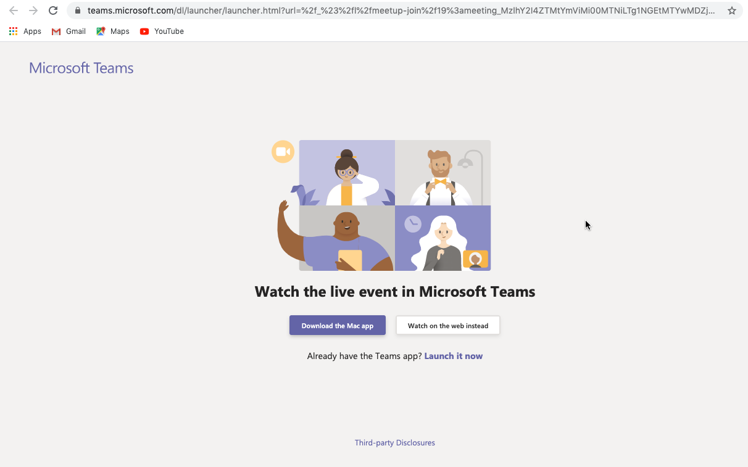
Step 2: If you do not wish to install the Teams app, click ‘Watch on the web instead’

Step 3: Sign in with your Microsoft account or choose to join anonymously if you do not wish to use your Microsoft account.
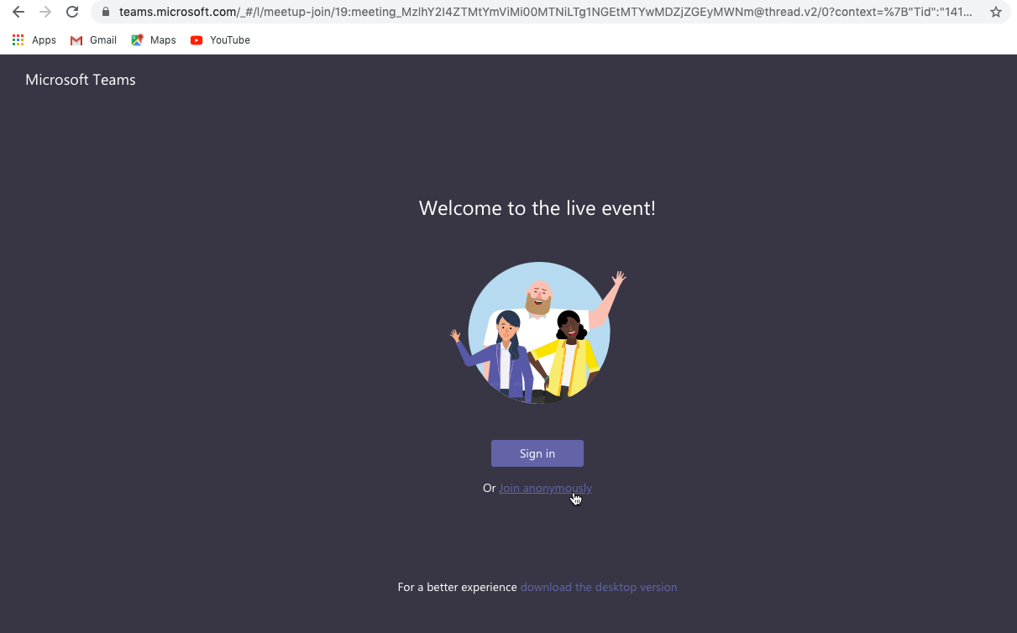

Step 4: You have now joined the meeting.
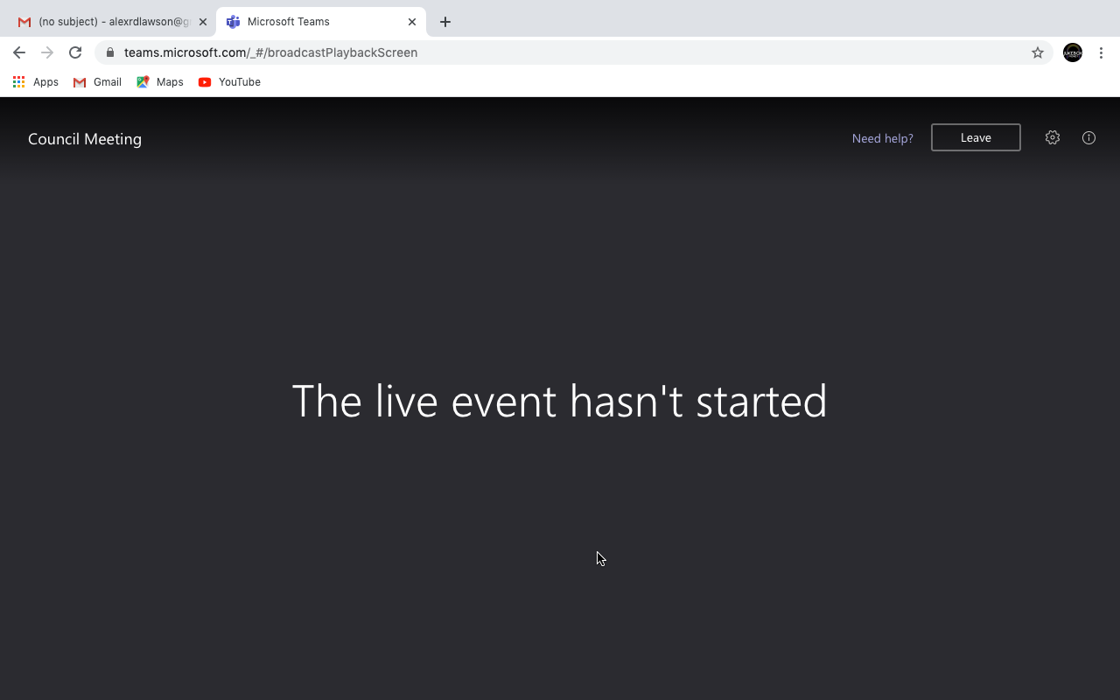

If you are joining from a mobile device or tablet please note the following:
Apple devices:
When using an iOS device (iPhone/iPad), Teams Meetings will not be compatible directly with the Safari browser. To access Teams Meetings from your iOS device, please install the Microsoft Teams app from the App Store.
Android devices:
When using an Android device (Mobile or Tablet), Microsoft Teams Meetings / Live Events will not be compatible when in Mobile View, set your browser to Desktop Mode or download the Microsoft Teams app from the Play Store

